1

Stevens Stadium Events Evacuation Plan

Santa Clara University
500 El Camino Real
Santa Clara, CA 95053

April 29, 2016

Table of Contents
Contents
Purpose 3
Scope 3
References 3
Application 3
Roles and Responsibilities 3
Permits 4
Pre-Event Evacuation Announcements 4
Large Event Evacuation Procedures: 12
Medium Event Evacuation Procedures: 13
Small Event Evacuation Procedures: 14
Events with less 999 capacity 15
Fire Alarm Activation 15

Purpose
These procedures are intended to describe actions taken by SCU Staff during a major emergency that requires an evacuation of Stevens Stadium during Commencement Ceremonies.

Scope
The evacuation plan shall cover those designated actions that Stadium Management, Staff, Campus Safety and Spectators must take in order to ensure safe and secure evacuation in the event of an emergency.

References
- Attachment 1: Stevens Stadium Exiting Plan Map
- SCU Crowd Management & Emergency Planning, Response and Evacuation Policy Plan

Application
This program covers the minimum evacuation process requirements for SCU Commencement spectators and SCU Stadium Staff, Event Planners, Campus Safety and EHS.

Training
Training of the Crowd Control Managers will be completed by Campus Safety.

Roles and Responsibilities
Incident Commander: The person responsible for all aspects of an emergency response and manages all incident operations and applications of resources as well as responsibility for all persons involved.
Crowd Control Manager: One or more people who are assigned the responsibility of maintaining the safety of occupants during a gathering. This person is responsible for implementing the evacuation plan in the event of an emergency, panic or fire. Each Crowd Manager is responsible for monitoring groups of up to 250 people and ensuring they are protected from situations that could endanger the crowd (blocked aisles or egress routes). The proper ratio is one Crowd Manager per every 250 persons.
Event Planner: the person responsible for coordinating the planning of the event and ensuring the crowd management plan is implemented appropriately and communicated to all of the major event organizations (Emergency Management, EHS, Risk Management, and Campus Safety. The Event Planner ensures an adequate number of Crowd Managers are in place and assigns a Principal Crowd Manager to oversee (supervise) Crowd Managers, and assigns the Principal Crowd Manager.

Permits
Requirements-by Capacity:

Large – Events with a capacity of over 8,161 spectators:
- Special event permit from the City of Santa Clara showing:
  - Egress exit plan for the expected capacity
  - The areas of safe refuge
- In the East Structure, two new egress pathways to the field need to be open an portable stairs in place

Medium – Events with a capacity of at least 4,200 but fewer than 6,090 spectators:
- In the East Structure, two new egress pathways to the field need to be open an portable stairs in place
- No special event permits required

Small – Events having a capacity of less than 4,200 spectators:
- In the East Structure, the existing (original) egress pathways are sufficient to meet the attendance
- The two new field egress gates can remain secured in the closed position and the two portable stairs are not needed
- No special event permits required

Pre-Event Evacuation Announcements

- The Event Planner or their designee will address the spectators and instruct them to view the Jumbotron (see photo on page 9). The Jumbotron will display the outline of Stevens Stadium Site Exiting Plan. The Event Planner or their designee will describe the plan in detail. At that time the following information will be disseminated:
  - The East Structure and field seating has been divided into four sections (see Attachment A):
  - Section 1 (Northwest seating) is PINK
  - Section 2 (Northeast seating) is BLUE
  - Section 3 (Southeast seating) is GREEN
  - Section 4 (Southwest seating) is ORANGE
- In the event of evacuation, spectators will exit the venue utilizing the following egress pathways:
  - Section 1 (PINK): Utilize the Northwest service gate (i.e., fire truck service lane) behind the West Structure out to the public way
  - Section 2 (BLUE): Utilize the Northeast service gate (i.e., emergency medical service lane) and North Plaza gates out to the public way
  - Section 2 (GREEN): Utilize the two Northeast gate openings on to Stanton Field
  - Section 3 (ORANGE): Utilize the two Northwest gate openings on to Stanton Field

- The Event Planner or their designee will instruct the spectators where the exits are located.

- For those needing assistance out of the facility, they will be directed to the safe dispersal areas that are within the East Structure and then be escorted to the either Leavey Parking lot or the north exit.

- Crowd Control Officers will be staged at each exit and safe dispersal area as noted on the Stevens Stadium Site Exiting Plan. During the evacuation, the Crowd Control Officers will direct spectators to the areas of safe refuge as indicated on the Stevens Stadium Site Exiting Plan.

Dispersal Area #1
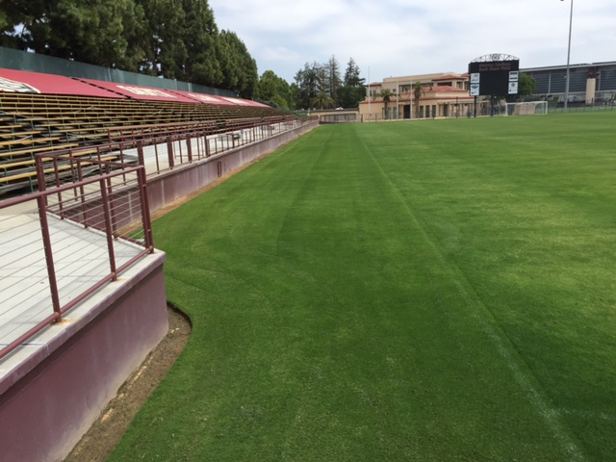

North Exit in the main Campus entrance
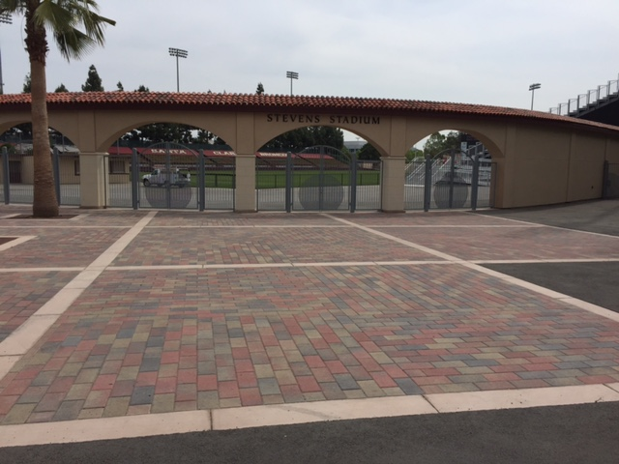

Dispersal Area #2
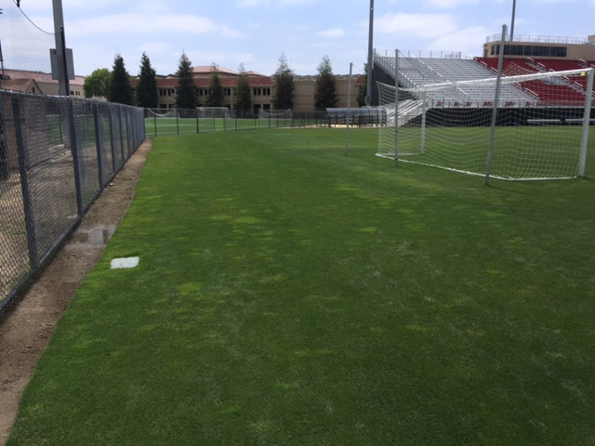

Dispersal Area #3
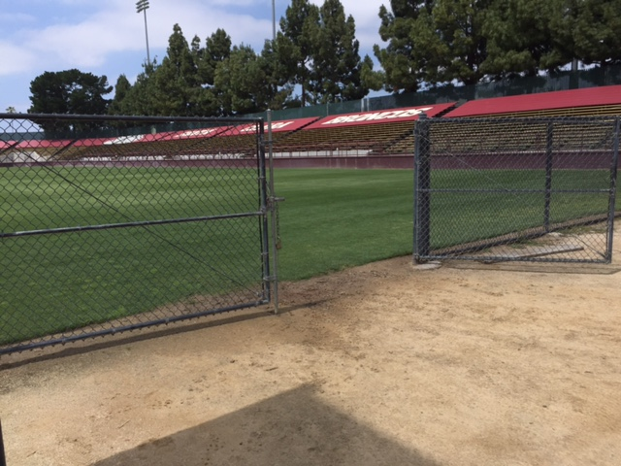

Southwest exit from west seating structures
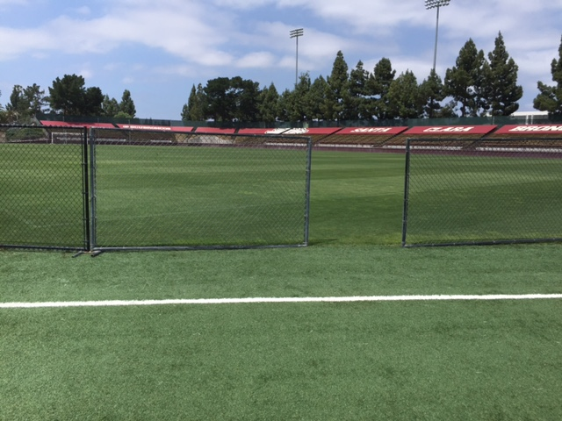

Northwest exit from field
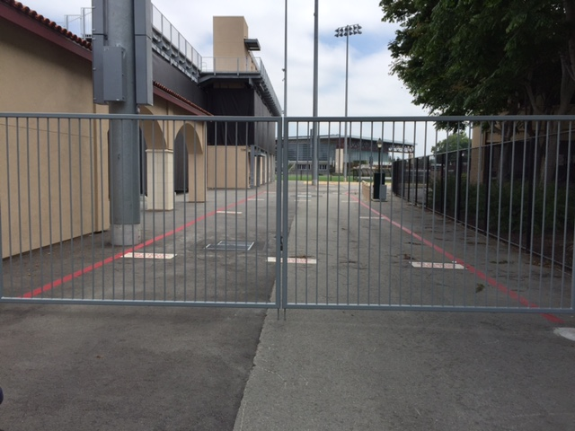

North Exit to Palm Drive
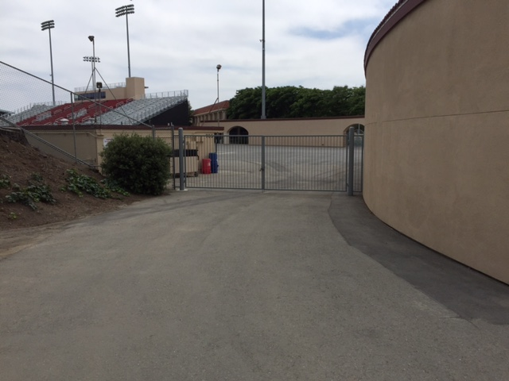

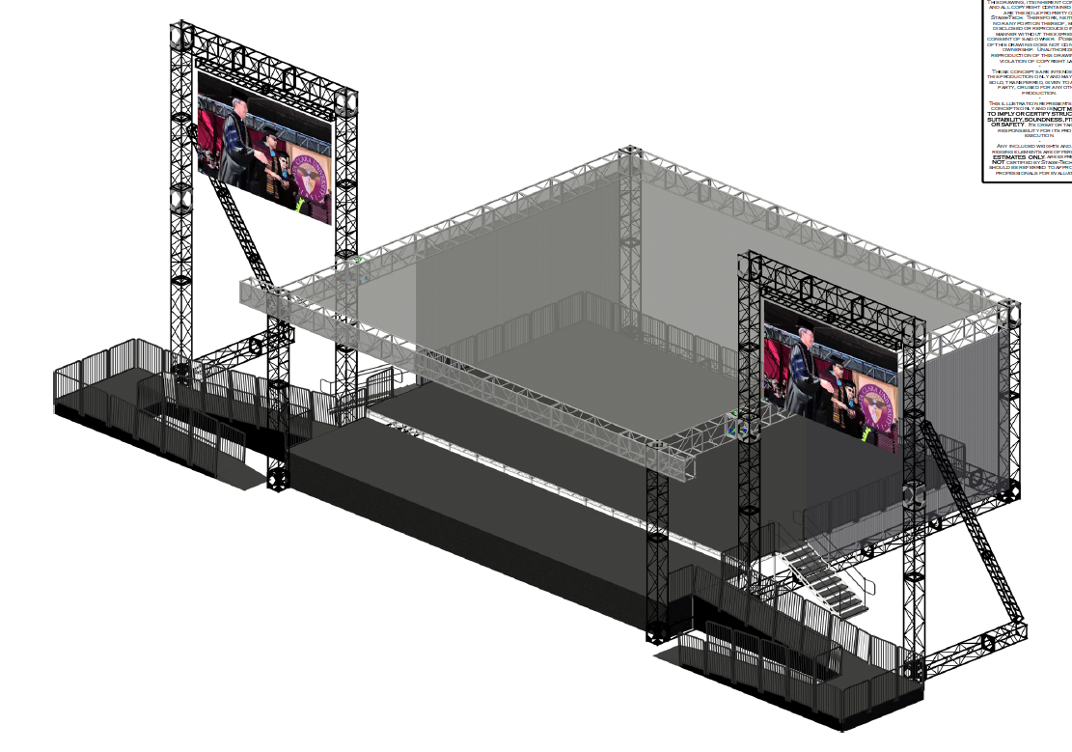

Large Event Evacuation Procedures:

- Upon the onset of an emergency requiring evacuation the east will be evacuated. The west structure will not be used for Commencement. The following actions will be undertaken during the emergency:

- The Event Planner, Campus Safety Official or designee will announce through the public address system the nature of the emergency with the following message:

“May I have your attention please; May I have your attention please! We are experiencing a _____________________emergency situation. Please evacuate the stadium and proceed to the safe dispersal area.” or a modified announcement may be used.

- Additional instructions will be announced via the public address system and crowd control officers will assist you in exiting the venue safely. Please evacuate in safe manner.

- Campus Safety Officers assigned to the event will open all gates. Move all tables, carts and gate counters and clear the exits as much as possible.

- Crowd control staff and ushers should remain at their assigned location and direct spectators in accordance with the direction issued by Incident Command.

- All Spectators and other staff should be directed to the nearest egress pathway which leads to the area of safe refuge and then onto the exits as designated on the Stevens Stadium Site Exit Plan.

- There are four major exits from the stadium. A Campus Safety Officer will be assigned to assist in the evacuation of the spectators.

- Everyone will remain in place until an “all clear” is issued through the Public Address or SCU campus alert system.

- Campus Safety Staff on the field will direct anyone evacuating onto the field to the exits and to the appropriate parking lot.

- Attendees north of the 50-yard line shall evacuate north to Emergency Assembly point on Palm Drive

- Attendees south of the 50-yard line shall evacuate south to the Emergency Assembly point adjacent to Locatelli and the Alumni Parking lot (adjacent to Leavey).

- The Stadium Incident Commander and/or Campus Safety Services dispatch will initiate notification to the Santa Clara Police Department of the stadium evacuation in order to facilitate traffic flow away from the stadium. This may be performed with prior consult with the CSS Assistant Director / Director.

- After the stadium is cleared, all crowd management staff will evacuate the stadium.

- Parked vehicles will not be allowed to leave or congregate through the Leavey Parking lot while the evacuation situation is active – this is to prevent the risk of evacuees being struck by moving vehicles

- The Crowd Control Officers and or Campus Safety Officers will be staged at exit pathway and safe dispersal areas to further assist the spectators to the nearest exits.

- Further direction will be at the discretion of the SCU Campus Safety Office and the Santa Clara Police and Fire Departments if needed.

- SCU Campus Safety will be the contact for emergency units.

- Campus Safety will give the “All Clear” signal to re-enter the facility.

- At the conclusion of the evacuation a briefing to review any issues of the stadium evacuation.

Medium Event Evacuation Procedures:
- Upon the onset of an emergency requiring evacuation the east and west seating structures will be evacuated. The following actions will be undertaken during the emergency:

- The Event Planner, Campus Safety Official or designee will announce through the public address system of the nature of the emergency and announce the following message:

“May I have your attention please; May I have your attention please! We are experiencing a _____________________emergency situation. Please evacuate the stadium and proceed to the safe dispersal area. Or a modified announcement may be used.

- Additional instructions will be announced via the public address system and crowd control officers will assist you in exiting the venue safely. Please evacuate in safe manner.

- Campus Safety Officers assigned to the event will open all gates. Move all tables, carts and gate counters and clear the exits as much as possible.

- Crowd control staff and ushers should remain at their assigned location and direct spectators in accordance with the direction issued by Incident Command.

- Further direction will be at the discretion of the SCU Campus Safety Office and the Santa Clara Police and Fire Departments if needed.

- SCU Campus Safety will be the contact for emergency units.

- Campus Safety will give the “All Clear” signal to re-enter the facility.

- A briefing will be conducted to review any issues arising from of the evacuation.

Small Event Evacuation Procedures:
- Upon the onset of an emergency requiring evacuation of the east and west seating structures will be evacuated. The following actions will be undertaken during the emergency:

- The Event Planner, Campus Safety Official or designee will announce through the public address system of the nature of the emergency and announce the following message:

“May I have your attention please; May I have your attention please! We are experiencing a _____________________emergency situation. Please evacuate the stadium and proceed to the safe dispersal area. or a modified announcement may be used.

- Additional instructions will be announced via the public address system and crowd control officers will assist you in exiting the venue safely. Please evacuate in safe manner.

- Campus Safety Officers assigned to the event will open all gates. Move all tables, carts and gate counters and clear the exits as much as possible.

- Crowd control staff and ushers should remain at their assigned location and direct spectators in accordance with the direction issued by Incident Command.

- Further direction will be at the discretion of the SCU Campus Safety Office and the Santa Clara Police and Fire Departments if needed.

- SCU Campus Safety will be the contact for emergency units.

- Campus Safety will give the “All Clear” signal to re-enter the facility.

- A briefing will be conducted to review any issues arising from of the evacuation.

Events with less 999 capacity
Events with less 999 spectators do not require Crowd Control Managers.

Headcount- Spectators

Event Staff will be stationed at the two main entrances (North Gate and South Gate) and equipped with mobile ticket scanners. Each spectator will have his or her ticket scanned for entry. Spectators on the field will have their hand stamped should they need to temporarily leave field seating for restrooms or concessions within the stadium. A stamped hand and original ticket must be in hand to re-enter the field. Re-entry into the venue itself will not be permitted. The Incident Commander and Event Planner monitors the live headcount throughout the event.

Fire Alarm Activation

During an event if the fire alarm sound and automatic response is triggered which will cut off the live event audio and video. The stadium audio and video systems will then go into emergency response mode which will then play a prerecorded audio and video message stadium wide. The audio message will be “Please standby for further instructions. Thank you”. The video board will display the same message in white or yellow text on the black background. Once the message is displayed the emergency services team will instruct the occupants on the best course of action.

